Algebra 1: Unit 10, Lesson 1

- The graph of an absolute value function is shown on the coordinate plane.
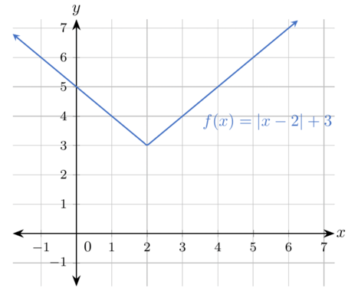
What is the axis of symmetry?
$$x=2$$

- An absolute value function is shown.
$$f(x)=|x-2|+4$$

Complete the table of values for the absolute value function.
$$7$$
$$x$$ | $$y$$
$$-2$$ | $$8$$
$$-1$$ | ______
$$0$$ | $$6$$
$$1$$ | $$5$$

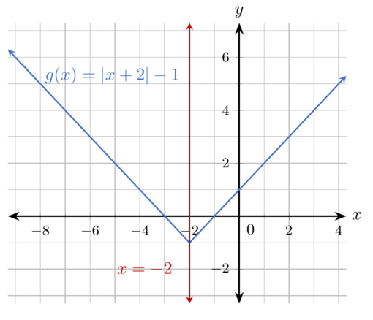
- The graph of the absolute value function $g(x)=|x+2|-1$ and the graph of its axis of symmetry, $x=-2$, are shown on the coordinate plane
Which point on the graph $g(x)=|x+2|-1$ is the same distance as $(-3,0)$from the axis of symmetry on the opposite side of the graph?
$(-1,0)$

